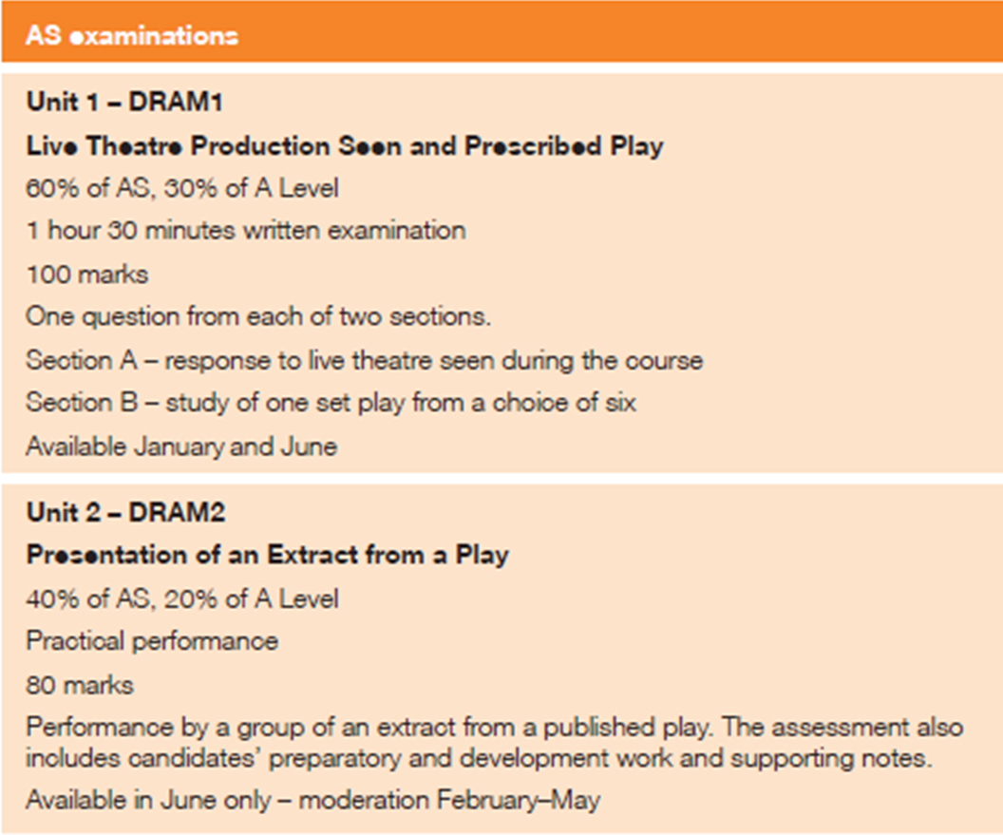

AO2- Requires candidates to ‘demonstrate knowledge and understanding of practical and theoretical aspects of drama and theatre using appropriate terminology’ all areas of the course. AO1 is out of /17 in the written exam

AO3- requires that candidates ‘interpret plays from different periods and genres’ JSM covers with a Doll’s House analysis for the written exam. AO3 is out of /33 in the written exam

AO4- requires that candidates ‘make critical and evaluative judgements of live theatre’. – HJO covers with theatre review section of written exam.

Section A SOW covered by HJO and is titled: ‘Theatre Review Scheme of work’

Section B SOW covered by JSM and is titled: ‘A Doll’s House’ by Ibsen looking at 19th Century play text.

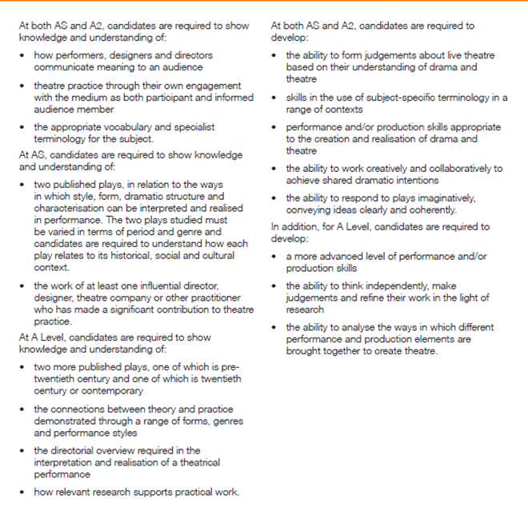

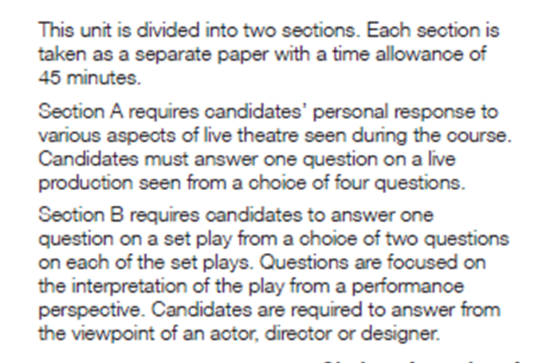
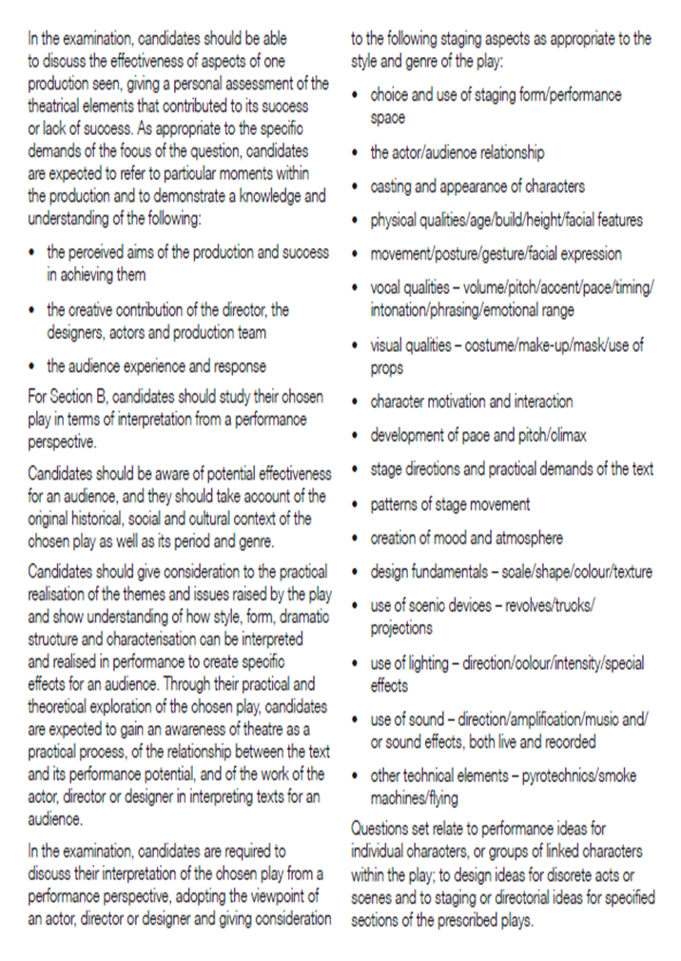

Y12 Lessons on A Doll’s House:

Lesson 1
- Enter and do Stanislavski’s Given Circumstances and they improvise dinner service.
- Give them text and explain that each character is similar to those in the play.
- Hand out texts and they have to read over the week.

- presentations on each character looking at: (2 lessons prep and two presentations)
- 3 Key moments
- characters journey AO3
- relationship with other characters AO2 and 3
- casting ideas and comparisons (including costume ideas) AO2 and 3
- audiences general response to the character both 19th century and contemporary AO2
- link the character to social context: bourgeoisie, etiquette, decorum, moral scruples. AO2
- key Quotes for the characters
- develop audience response in key sections above using gingerbread man.
(these will be emailed to me and printed off for the lesson for them to annotate) AO3

Lesson 2: prep lesson (preferably ICT suite)

- Presentations
- Presentations

- Use presentation notes to do a plan in the same groups on the next character in rotation. They must complete one to photocopy by the end of the lesson:
- How would you direct the character of………….. in their first entrance of the play, linking it to the rest of the play, to show your overall interpretation of the character.
- They must include in their plan:
  - Plot in relation to the character, and where the key moments link to the rest of the play in regards to where the character is emotionally at, during these sections. AO2
  - Character relationships with each other and the audience. Do both of these change and the play evolves. AO2
  - When they enter in relation to the text and what this says about IBSEN’s structuring. AO2
  - Page numbers and quotes. AO2
  - Clear interpretation that the essay can support in the intro and conclusion. (teacher to photocopy into a booklet for next lesson) AO2 and 3

Lesson 3:
Each group now does the next character in rotation essay plan that they will complete as homework. Go through the spider diagram called: things to include in your essay. This must be implemented into the essay play and go though what makes a good student.
- Making personal notes on every sheet I give them or go through.
- Organising their work into categories.
- Being prepared for lessons
- Doing extra research if they are not understanding period etc.
- Rereading the text regularly and making pencil notes in the text.
- Actively using the text in lesson.

- Go through Mcormick’s essay on Nora to show them how their essay could be written. Highlighting key points. Referring to the spider diagram.
- Make sure they are clear of the structure of an essay: intro:

Include how you want a 19th century and a contemporary audience to respond and why (link to your vision of the character and support this with knowledge AO2 of etiquettes etc). explain the change or development you want the audience to undergo. Then paragraph 2 set the scene in relation to where it is in the play, then do a practical analysis / gingerbread man – of what they will be doing. Then bridging paragraph of how the play evolves and the audiences opinions are changed or developed, then do Paragraph 3 the same as paragraph 2 but of a different section that shows great differing qualities to the character. Explain in the gingerbread how they will move in regards to their costume and whether they have changed it. Then conclusion.

- H/W: do essay. Don’t do it as a timed essay but do it well as it is an indication as to how much work you need to do. AO2 and 3

Lesson 4:
Spider diagrams on all characters – Pages they are in, opinions of them, purpose to plot, vision they have of them, relationship with others, how they present the style and period. Go though character sections/ appearances in the play in detail and decide which moments could be used for each character and why.

Lesson 5: Set designs and symbolism. PPT on IBSEN’s life. They can use to layer their essay.

- Symbolism, props and set. Draw their own and look at mine for reference. (you could use the PPT). They must look through the text for stage directions and quotes to support why the stage and props are used and why they are symbolic must be clearly labelled.
- H/W: do research on the women’s role in society and appropriate etiquette in the 19th century and stereotypical living. E.g. jobs, interests, education, hobbies.

Lesson 6: Units and objects and appearances. See lesson plan.

Lesson 7: watch film and make notes on section of it, key character journey and units and objectives. Critically evaluate whether you would direct them in the same way.

Lesson 8: in the section they worked on analyse the text in regards to English / language, subtext etc.

Lesson 9: PPT on structuring an essay and link to the varying kinds of questions for the next 2 lessons.

Lesson 10 and 11:

- Go through essay questions and put which moments will be used for each question.
- Create essay plans for all questions.

Lesson 12:
Go through past essay questions and what the exam board would require / criteria for each question. Specialising in AO2 and AO3. They mark them accordingly and give feedback to group. (see exam marked essay packs)
- H/W: If possible choose a character you haven’t done yet and answer that one off the two the exam board have given us reference on.

Lesson 13: look at sample essays

Lesson 14: (this takes about 4 sessions)
Nora: what bits do we use for a question on her:
- Stress level chart
- Key scenes she is in
- Her relationship with individual characters
- Rehearse scenes with: Rank, Christine, Krogstad and the opening and end with Torvald.
- All watch and make notes.
- Debate about interpretation embedded
- Now which sections to use in which questions

Lesson 15: Nora essay:
Go through McCormicks essay then do essay plan and write the essay on Nora. If criteria is there use it. (see resource typed – i did marking criteria sheet).

Lesson 16: question on relationships presented between Rank and Nora/ Torvald and Nora / Christine and Nora / Krogstad and Nora – using past papers.

Lesson 17: clearly going through the following question:
How would you want the audience to respond to Nora, using at least two sections to show how she interacts with others. Explain how you would stage these sections to achieve your aims
- What do you think they will want you to cover?
- How she is manipulated / manipulative
- How some characters bring different characteristics out in her.
- Sound theatrical understanding
- Use text to support vision
- Make reference to period / genre
- You might include sympathy, tension, anticipation, shock.
- Costume used how and set / furnishings = naturalism / lighting / sound to highten tension, or emphasis the moment. Make-up.
  - Physical appearance
  - Vocal qualities
  - Delivery of lines, interaction with others, eye contact, physical contact, use of space, special relationship, movement, gestures, posture, energy, demeanor and facial expressions.
Do an essay plan – H/W finish essay use pages.

