

Aims

Assessment (see photocopy) (pg. 28)

Assessment outline—SL and HL

**External assessment**

**Task 1: Solo theatre piece (HL only) KAG May 2016 perf, Sept 2016 report**

 Students at HL research a theatre theorist they have not previously studied,

identify an aspect(s) of their theory and create and present a solo theatre

piece (4–8 minutes) based on this aspect(s) of theory.

**N/A 35%**

**Task 2: Director’s notebook (SL and HL) JSM March 2016**

 Students at SL and HL choose a published play text they have not

previously studied and develop ideas regarding how it could be staged for

an audience.

**35% 20%**

**Task 3: Research presentation (SL and HL) HJO July 2016**

 Students at SL and HL plan and deliver an individual presentation (15

minutes maximum) to their peers in which they outline and physically

demonstrate their research into a convention of a theatre tradition they have

not previously studied.

**30% 20%**

**Internal assessment**

**Task 4: Collaborative project (SL and HL) ALL Y13, Feb 2017 perf, March 2016 portfolio**

 Students at SL and HL collaboratively create and present an original piece

of theatre (lasting 13–15 minutes) for and to a specified target audience,

created from a starting point of their choice.

**35%**

Theatre aims

The aims of the theatre course at SL and HL are to enable students to:

1. explore theatre in a variety of contexts and understand how these contexts inform practice (theatre in context)

2. understand and engage in the processes of transforming ideas into action (theatre processes)

3. develop and apply theatre production, presentation and performance skills, working both independently and collaboratively (presenting theatre)

For HL only:

4. understand and appreciate the relationship between theory and practice (theatre in context, theatre processes, presenting theatre).

Overview of the course

**Core areas**

The theatre syllabus at SL and HL consists of **three** equal, interrelated areas:

***Theatre in context***

*This area of the syllabus addresses the students’ understanding that theatre does not occur in a vacuum. Students examine the personal, theoretical and cultural contexts that inform theatre -making and the ways in which these affect and influence creating, designing, directing, performing and spectating. Through the theatre in context area, students*

*will:*

*• understand the contexts that influence, inform and inspire their own work as theatre-makers and that determine the theatre that they choose to make and study*

*• experience practically and critically appreciate the theoretical contexts that inform different world theatre practices*

*• be informed about the wider world of theatre and begin to understand and appreciate the many cultural contexts within which theatre is created.*

***Theatre processes***

*This area of the syllabus addresses the students' exploration of the skills, techniques and processes involved in theatre-making. Students reflect on their own creative processes and skills acquisition as well as gaining a practical understanding of the processes of others; creators, designers, directors and performers.*

*Through the theatre processes area, students will:*

*• be informed about the various processes involved in making theatre from the perspectives of the specialist theatre roles (creator, designer, director and performer)*

*• observe and reflect on processes used in different theatre traditions and performance practices*

*• develop a range of skills required to make and participate in theatre*

***Presenting theatre***

*This area of the syllabus addresses the staging and presentation of theatre as well as the presentation of ideas, research and discoveries through diverse modes of presentation, both practical and written.*

*Students consider the impact theatre can have on the spectator. They are encouraged to think about their own artistic intentions as creators, designers, directors and performers and the impact they wish to have on an audience.*

*Through the presenting theatre area, students will:*

*• apply their practical theatre skills, either individually or collaboratively, through a range of formats• present their ideas about theatre and take part in theatre performance• understand and appreciate how artistic choices can impact on an audience.*

Overview of the course

**Core areas**

The theatre syllabus at SL and HL consists of three equal, interrelated areas:



**Figure 2**

These core areas, which have been designed to fully interlink with the assessment tasks, must be central to the planning and designing of the taught programme developed and delivered by the teacher. Students are required to understand the relationship between these areas and how each area informs and impacts their work in theatre.

Students are required to approach these areas from the perspectives of each of the following specialist theatre roles:

1. creator – [Collaborative Project]
2. designer – [Collaborative Project and DN]
3. director – [Director’s Notebook]
4. performer – [Solo & Research Project]

Be good ‘Reflectors’

What is reflective writing?

Reflection is an exploration and an explanation of events – not just a description of them

1 Looking back at something (often an event, i.e. a moment in a play or a breakthrough in rehearsal).

2 Analysing the event or idea (thinking in depth and from different perspectives, and trying to explain, usually in reference to the effect on an audience/ dramatic intention)

3 Thinking carefully about what the event or idea means for you and your ongoing progress as a learner and/or Performer, Director, Creator or Designer.

***In all assessment around a quarter of the marks are gained for the quality of your reflection on the project.***

***In order to effectively reflect you should consider the following-***

**IB learner profile- Inquiry** (what was interesting, look deeper into something), **knowledge** (what knowledge have you gained), **Critical thinking** (evaluate how you were able to perform/ direct/ create in the project), **communication** (how able were you to communicate your aim), **Principles** (where did you have to compromise, where did you effectively stick to your feelings?), **Open Mindedness** (how open were you to new traditions/ ideas- how have these benefitted you as a dramatist), **Caring** (were the needs of your audience met? Have can this theatre benefit the wider community), **Risk Taking** (thoughtfully consider our own ideas and experiences), **Balanced** (consider strengths and weaknesses)

**Structure for reflection-**

1 Description (keep this bit short!)

|  |  |  |  |
| --- | --- | --- | --- |
| What happened?  What is being examined? | 2 Interpretation   |  |  | | --- | --- | | What is most important / interesting / useful / relevant about the object, event or idea?  How can it be explained e.g. with theory?  How is it similar to and different from others? |  | |

3 Outcome

|  |  |
| --- | --- |
| What have I learned from this?  What does this mean for my future? | *.* |

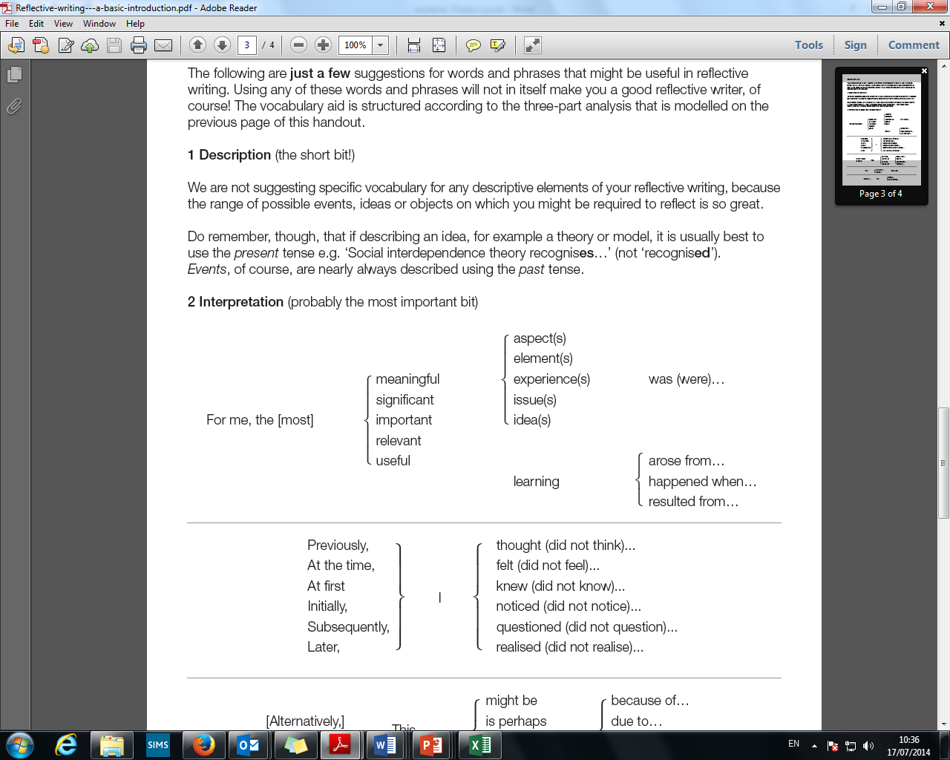

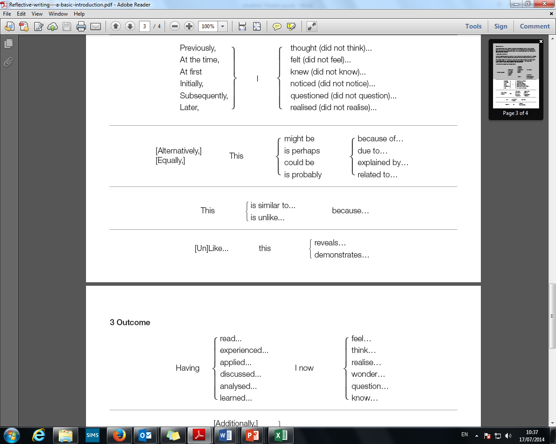

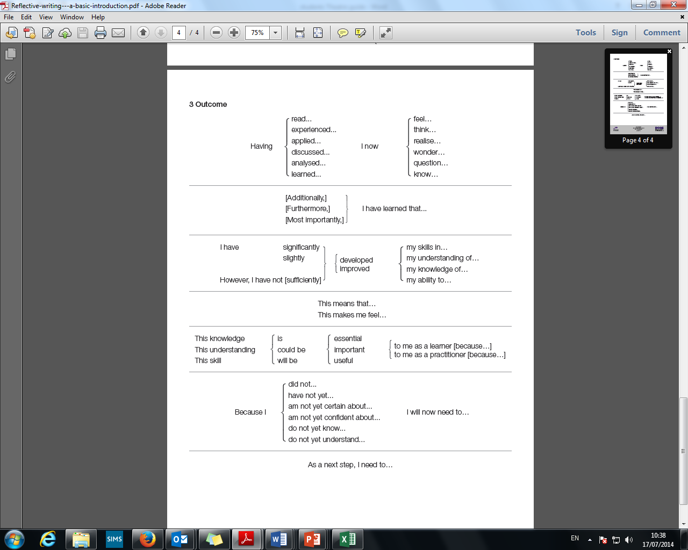

Quick Explanation of Terminology

**Designer** (costume, lighting, make up, sound or set)- person responsible for creating one or more of the design and technical elements of a play.

**Performer**- An actor, puppeteer, musician or voice over [RP &SOLO]

**Director**- oversees and orchestrates the mounting of a theatre production, is responsible for overseeing all areas (acting, design and technical) [DNB]

**Creator**- could be a playwright. producer or a member of a company that devises- simply a person who creates theatre. [COLLAB]

**Theorist**- An *individual* with clear and documented views on how theatre should be presented (techniques, design style, technological style)

**Practitioner**- (similar to a theorist) an *individual*, professional theatre maker with a clear theatrical practice. (techniques) [Solo]

**Theatre Company**- A *group* of professional dramatists who work collaboratively with a shared artistic aim to create work theatre [Collab]

**Artistic Director**- Leader of a theatre company (can often be deemed as a practitioner or theorist in their own right) [Collab]

**Theatrical Style**- a broad term that can be roughly applied to a type of theatre (eg Physical Theatre, Adaptation, Immersive Theatre)

**Theatre Tradition**- Theatrical Styles that are exclusive or typical of specific periods of time or specific countries. (eg Renaissance Theatre 16th and 17th century or Japanese Kabuki Theatre) [RP]

Assessment in detail broken down

External assessment

The method used to assess students in theatre is detailed assessment criteria specific to each assessment task. The assessment criteria are published in this guide and are related to the assessment objectives established for the theatre course and the arts grade descriptors.

External assessment details—HL only

**Task 1: Solo theatre piece (HL only)**

**HL 35%**

**Introduction**

Students at HL research a theatre theorist they have not previously studied, identify an aspect (or aspects) of their theory, create and present a solo theatre piece (4–8 minutes) based on an aspect(s) of this theory.

This task develops, builds on and extends the skills and understandings developed in the other areas of the syllabus. It requires students to create a fully produced piece of theatre based on theatre theory. Students submit a report (maximum 3,000 words) which includes their research into and understandings of the theorist, the theory and the context of the theorist’s work. It also records their practical explorations of the selected aspect(s) of theory, the development of the solo theatre piece and analysis and evaluation of the theatre piece.

Perspective—candidates should approach this task from the four perspectives of creator, director, designer and performer.

This task does not assess performance skills, but rather the extent to which students can learn, embody and communicate understanding through action.

**Requirements of the video recording**

The video recording must be a continuous, unedited record and must capture the full theatre piece. The video camera must not be switched off at any point during the presentation.

**Other performers**

This is an individual assessment task which requires the student to present a solo theatre piece. Other performers are **not** permitted to appear in any part of the final presentation of the solo theatre piece.

**Assessing the task**

Students then undertake the following process for assessment.

***Theatre in context***

*• Each student selects a theatre theorist whose work interests them and who they have not previously studied as part of their IB programme. The selected theorist may have been referred to or experienced in a workshop but must not have been taught as the focus of a unit of work by the teacher.*

*• Each student selects an aspect (or aspects) of the theatre theorists’ theory they want to explore further.*

*• Each student researches the selected aspect (or aspects) of theory using both primary sources (those directly attributed to the theorist) and secondary sources.*

*• Each student documents this in their theatre journal.*

***Theatre processes***

*• Each student engages in a process of practical exploration of and experimentation with the theatre theory they have selected to develop a solo theatre piece.*

*• Students may choose to use or adapt existing text, create new text or not use any text, as appropriate to the theorist, the nature of the theory being explored and the stated intentions for the piece.*

*• Each student documents this in their theatre journal.*

***Presenting theatre***

*• Each student presents a prepared solo theatre piece to an audience. The theatre pieces may be presented in a formal or informal performance space as appropriate to the school’s resources and to the selected theorist and nature of the theory being explored.*

*• The audience for this task can be fellow classmates, peers or an external audience selected by the student.*

*• Each student evaluates their solo theatre piece and the extent to which they fulfilled their intentions. They reflect on the insights gained through the creation, preparation and presentation of their solo theatre piece.*

*• Each student documents this in their theatre journal.*

**Selecting the theatre theorist and theory**

Students at HL identify a theatre theorist they have not previously studied who has developed and contributed to theatre theory. Students should have little or no previous experience of researching or practically engaging with the theatre theorist or aspect(s) of theory they select for study.

It is important that the theatre theorist selected has made a significant contribution to theatre and that their theories are documented and publicly available. Published or recorded material of the theorist’s actual words communicating their theatre theory must exist.

Students must ensure that the theory they select is related to theatrical theory, rather than to social, psychological, literary, historical or cultural theory. In some cases it may be necessary to consider other theories alongside the theatre theory, with theorists such as Augusto Boal (b.1931), for example, whose

theatre theory cannot be considered without exploring the wider political components of his work. However, this must be clearly justified in the report.

**Examples of possible theatre theorists, theories and solo theatre pieces**

The table outlines possible ways in which theatre theorists and their theories could feasibly form the basis of a solo theatre piece. The table also identifies examples of primary and secondary sources for these theorists. These examples are for guidance only and are neither prescriptive nor restrictive.

**Structuring the report**

The report, which can be up to 3,000 words in length, should adopt a formal, academic register but should be written in the first person, where appropriate, presenting the student’s personal discoveries, explorations, creation and the analysis of their theatre piece.

The student may use any relevant illustrations, annotated text, charts, mind maps, visuals, diagrams, or designs considered necessary. These must be clearly annotated and appropriately referenced to acknowledge the source, following the protocol of the referencing style chosen by the school. When students include any of their own photographs or images, these must also be identified and acknowledged in the same way. Any text that appears within a visual does not count as part of the word limit. There is no lower limit on the number of words a student can submit for this task and teachers are encouraged to remind students that their work will be assessed on how it best fulfils the assessment criteria for the task and not judged on how many words are submitted.

The report should contain a table of contents (which is excluded from the word count) and all pages should be numbered. The main body of the report should be structured using the following subheadings:

1. The theorist, the theory and the contexts

2. Practical explorations and development of the solo theatre piece

3. Evaluation of the solo theatre piece and my personal reflections

4. Students are required to submit a separate list of all sources cited.

The size and format of pages submitted for assessment is not prescribed. Submitted materials are assessed on screen and students must ensure that their work is clear and legible when presented in a digital, on-screen format.

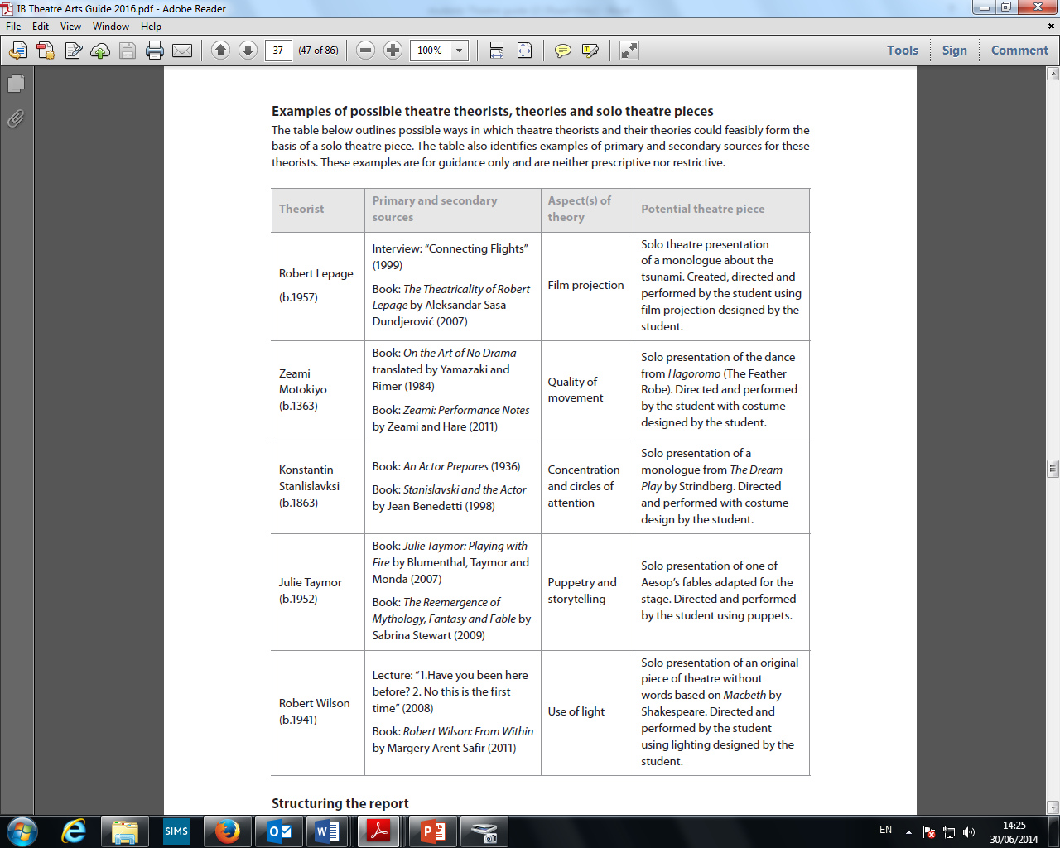

**Further examples of potential theorists**- Brecht, Berkoff, Peter Brooke, Jerzy Grotowski, Pina Bausch, Edward Gordan Craig, Antonin Artaud, Joan Littlewood, Mike Leigh, Katie Mitchell, Vsevolod Meyerhold , Dario Fo, Eugenio Barba, Anne Bogart, Tadashi Suzuki (and many more)

External assessment details—SL and HL (pg. 40)

**Task 2: Director’s notebook**

**SL 35%, HL 20%**

**Introduction**

Students at HL and SL independently choose a published play text, read the text and record their personal responses. They then:

• research and record the cultural and/or theoretical context of the play and identify ideas the playwright may be addressing

• explore the play and record their own ideas regarding how this play may be staged for an audience

• explain their directorial intention(s) and explain how this will inform their staging of **two** particular moments of the play; these can be moments of atmosphere, emotion or tension or which communicate the meaning(s) of the play; they must demonstrate an understanding of how performance and production elements function together to create these moments

• reference live performances they have experienced and how these have

influenced, inspired or informed their directing of these moments. The live theatre performances must not be productions of the same play text selected for study in this assessment task.

***Theatre in context***

*• Each student carries out research into the cultural context from which the play originates and/or research into the play text’s theoretical context, focusing on its style, form, practice or genre.*

*• Each student identifies the key ideas presented by the playwright (such as intended meanings, motifs, themes or throughline). As the author(s) of the text, the playwright might be one person, more than one person or in some cases a theatre company.*

*• Each student documents this in their theatre journal.*

***Theatre processes***

*• Each student records their interpretation of the selected play text and their artistic responses to the entire play text as a director, making links to live theatre performances they have experienced as a spectator that have influence, inspired or informed them. The live theatre performances must not be productions of the same play text selected for study in this assessment task.*

*• Each student records their exploration of the selected play text and their own ideas regarding how this play may be staged for an audience.*

*• Each student documents this in their theatre journal.*

***Presenting theatre***

*• Each student explains their directorial intention(s) and their intended impact on audience and demonstrates how this would inform their staging of* ***two*** *particular moments of the play. These can be moments of atmosphere, emotion or tension or moments that communicate the meaning(s) of the play.*

*• Each student demonstrates an understanding, through the staging of these two moments, of how performance and production elements function together.*

*• Each student documents this in their theatre journal.*

This process is recorded and presented in the form of a director’s notebook (20pages maximum) which is made up of visuals and words.

This is a theoretical exercise. The play text is **not** actually staged as part of the assessment task though a student may choose to work practically as part of the process of exploring the play or examining particular moments. Students are not permitted to edit, make additions or alterations to the play text selected for study. All sources must be acknowledged following the protocol of the referencing style chosen by the school.

Perspective—candidates should approach this task from the perspective of director.

**Assessing the task**

Students then undertake the following process for assessment.

This task is concerned with the textual exploration a director might carry out before they go into the rehearsal room to work with actors, defining what they want to bring out of the text and how it might look when finally staged. The process of how this might be achieved through rehearsals is not the focus of this task.

It is unlikely that a director would be responsible for the full scenic or technical design of the final theatre production; however their vision for the staging of the play text would certainly involve a clear understanding of how individual production elements might be employed to fulfil their directorial intentions and how these would potentially impact on the audience.

**Task details**

**Selecting the play text**

Students choose a published play text that they have not previously studied, which they are interested in practically exploring as a director and which would allow them to successfully fulfil the assessment requirements and criteria of the task. Students should have little or no previous experience of researching or practically engaging with the published play text they select for study.

**Discussing live theatre performance**

Students are required to discuss and make links to live theatre performances they have experienced as a spectator during the theatre course. Students should identify performances that have influenced, inspired or informed them and should pay particular attention to how directors employed production and performance elements to create effective moments of atmosphere, emotion or tension or moments that

communicated meaning in the live theatre performance experienced.

The live theatre performances identified must not be productions of the same play text selected for study in this assessment task. Students are not permitted to write about productions in which they have had involvement, for example school plays in which they helped backstage or local productions in which they performed.

**Structuring the director’s notebook**

The director’s notebook, which can be up to 20 pages in length, should be a combination of creative ideas, presented in both words and visuals, along with detailed ideas and explanations. The director’s notebook should be written in the first person and present the student’s personal interpretations, responses, ideas, discoveries and intentions for the proposed staging of their selected play text. Students should be as precise and specific as possible when discussing performance and production elements. The use of subject specific terminology may help to give a sense to this precision.

Students may use any relevant illustrations, annotated text, charts, mind maps, visuals, diagrams, designs and so on. These must be clearly annotated and appropriately referenced to acknowledge the source, following the protocol of the referencing style chosen by the school. When students include any of their own

photographs or images, these must also be identified and acknowledged in the same way. There is no lower limit on the number of pages that students can submit for this task and teachers are encouraged to remind students that their work will be assessed on how it best fulfils the assessment criteria for the task and not judged on how many pages are submitted.

The director’s notebook should contain a table of contents (which is excluded from the page count) and all pages should be numbered. The main body of the director’s notebook should be structured using the following subheadings:

1. The play text, its context and the ideas presented in the play

2. My artistic responses, creative ideas and explorations and my own experiences of live theatre as a spectator

3. My directorial intentions and the intended impact on an audience

4. How I would stage **two** moments of the play

**Students are required to submit a separate list of all sources cited.**

External assessment details—SL and HL (pg. 46)

**Task 3: research presentation**

**SL 35%, HL 20%**

**Introduction**

Students at HL and SL plan and deliver an individual presentation (15 minutes maximum) to their peers in which they outline their research and exploration of a theatre tradition they have not previously studied (selected from the prescribed list below). Students research the cultural and/or theoretical context of the selected theatre tradition and identify **one** performance convention from this tradition to explore practically and physically. The presentation must include a physical demonstration of the student’s practical and physical explorations of the performance convention and its application to a moment of theatre. The student then reflects on the impact this has had on them as a performer and as a learner.

Students submit a continuous, unedited video recording of the live presentation (15 minutes maximum) and a list of sources, as well as any additional resources they have used in their presentation that is not clearly seen or understood within the video.

Perspective—candidates should approach this task from the perspective of performer.

**Task details**

**Choosing the world theatre tradition and one performance convention**

A theatre tradition has a fixed set of specific performance conventions that are ways of doing things and have not changed significantly over time. Students select a world theatre tradition that they have not previously studied from the prescribed list below. Students should have little or no previous experience of researching or practically engaging with the particular theatre tradition they select for study.

**\*Students must select one of the theatre traditions from the prescribed list.**

**Other performers**

This is an individual assessment task which requires each student to deliver a solo presentation. Other students or peers are **not** permitted to appear in the presentation.

**Assessing this task**

Students then undertake the following process for assessment

***Theatre in context***

*• Each student chooses and researches a world theatre tradition they have not previously studied in depth from the prescribed list below. They research the cultural and/or theoretical context of the selected world theatre tradition.*

*• Each student identifies the performance conventions required by a performer in the world theatre tradition and selects* ***one*** *of these performance conventions to physically and practically explore for this task. Each student examines the* ***one*** *performance convention within the context of the world theatre tradition from which it originates.*

*• Each student documents this in their theatre journal.*

***Theatre processes***

*• Each student physically and practically explores the* ***one*** *performance convention they have selected and records the processes they undertake to develop the necessary skills for this exploration.*

*• Each student begins to practically examine how the selected performance convention could be physically applied to a moment of theatre. The moment they select may be from the world theatre tradition itself, from another theatre practice or may be material generated by the student. It should be selected in order to demonstrate the particular performance convention selected.*

*• Each student documents this in their theatre journal as they reflect on the development of their skills and knowledge and the process of exploring what is necessary to be a performer in this world theatre tradition.*

***Presenting theatre***

*• Each student presents the world theatre tradition, its contexts and the identified performance convention.*

*• Each student presents the processes they have undertaken to practically and physically examine this convention.*

*• Each student demonstrates and explains how they have applied this convention to a moment of theatre. This is presented as a “work in progress” and is not polished or fully produced.*

*• Each student presents their reflection on the impact this investigation has had on them as a performer and as a learner.*

*The entire presentation (maximum 15 minutes) is delivered to the teacher and to peers and is filmed as a continuous unedited shot.*

**Supplementary materials**

Students can use any relevant and appropriate supplementary materials that will enhance the presentation of their research into performance and demonstrate the process of their explorations (such as projections, video extracts, hand-outs, images, props, photographs and so on). Where these are not clearly visible within the video recording of the presentation, students should submit them with the list of sources which is submitted as a requirement alongside the video recording.

**Requirements of the video recording**

As this external assessment is assessed on screen it is crucial that the video recording captures the full presentation. The video recording must be a continuous, unedited record and must capture any additional resources used during the task. The video camera must not be switched off at any point during the assessment task.

**\*Examples of possible scenarios, scenes or sequences**

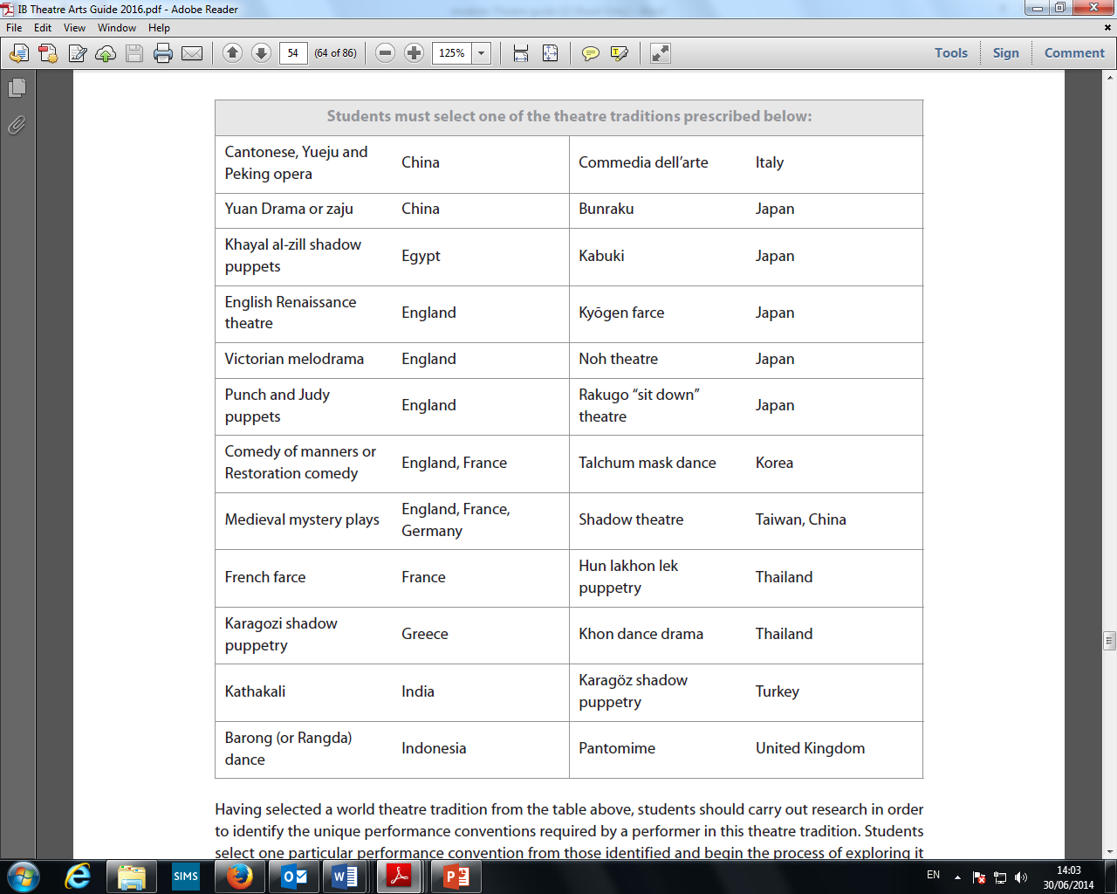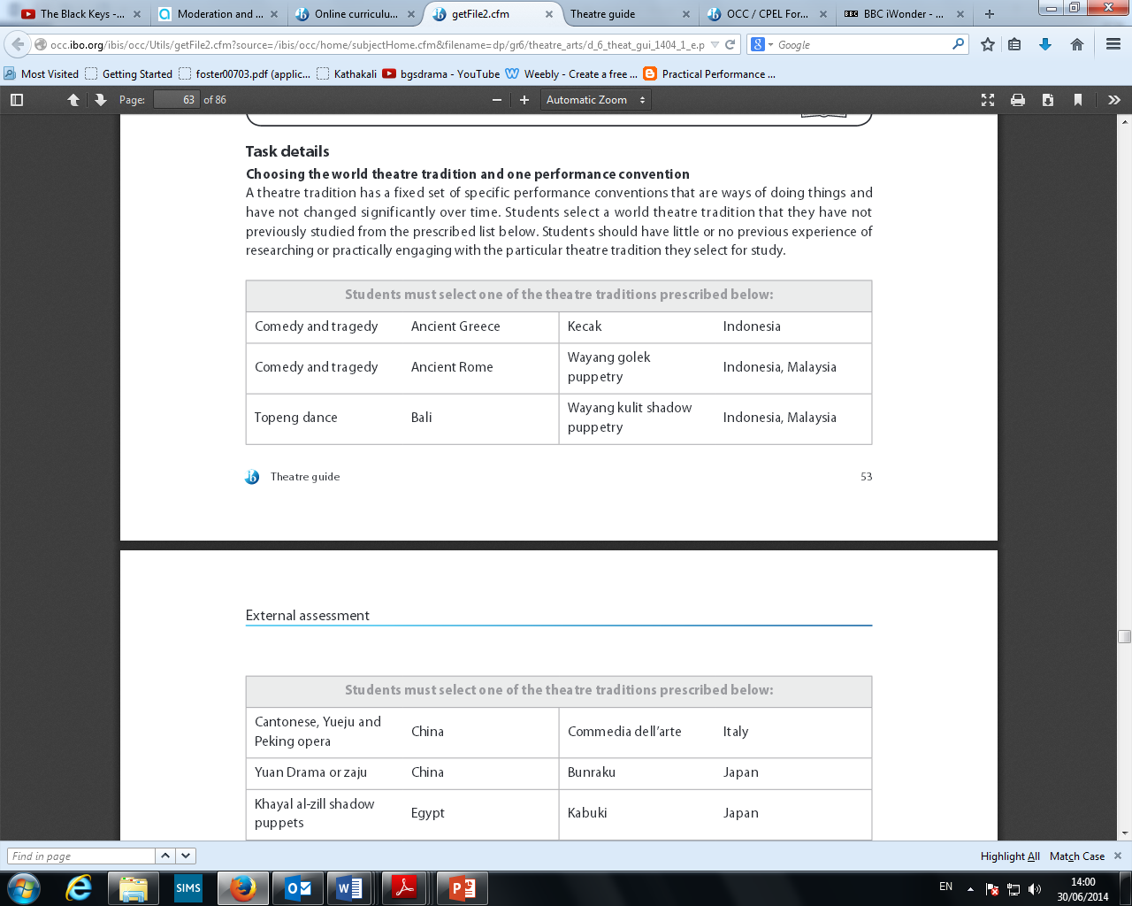

Internal assessment tasks—SL and HL

**Task 4: Collaborative project**

**SL 35%, HL 25%**

**Introduction**

Students at HL and SL collaboratively create and present an original piece of theatre (lasting 13–15 minutes) to a specified target audience from a starting point selected by the ensemble. They submit a process portfolio (15 pages maximum) which documents their own individual approaches and skills, the exploration of the starting point selected by the ensemble, the nature of the collaboration and the student’s

individual contribution to the creation and presentation of the piece of theatre. The student submits a video recording (4 minutes maximum) in support of the process portfolio which the student selects from the unedited video recording of the created piece.

Perspective—all students approach this task in the role of collaborative creators of original theatre within an ensemble.

**Assessing this task**

Students then undertake the following process for assessment.

**The nature of collaboration**

This is a collaborative project and students must work with at least one other person and with no more than five other students (making a maximum ensemble size of six). In instances where there are fewer than two students, students may work with peers that are not in the theatre class, such as theatre students from the year below, or others who are not taking the IB Diploma Programme theatre course (as long as the

ensemble size does not exceed six).

**Task details**

***Theatre in context***

*• Each student reflects on their own personal context, identifying their own approaches, interests and skills in theatre, with a view to using this information to determine who they will collaborate with for this project.*

*• Each student researches the work of a professional company that creates and stages original pieces of theatre (not already studied in depth as part of the theatre course) and examines the approaches employed by the professional company. This research may take a variety of forms, such as websites, published articles, direct communication with the company, interviews and experiences of practical workshops, for example.*

*• In light of the process above, students form groups (ensembles) of no more than six people with whom to collaboratively create. Each ensemble collaboratively selects a starting point (idea, issue, theme, non-dramatic text, music, object, image, event or site) that they feel has potential for development into an original piece of theatre.*

*• Each student researches the selected starting point, identifying its theatrical possibilities and presenting this to the ensemble.*

*• The ensemble uses the research to formulate their intentions for the piece. They select a target audience and identify their intended impact on this target audience.*

*• Each student documents this in their theatre journal, paying particular attention to their individual approach, research and contribution to the collaborative process.*

***Theatre processes***

*• Each ensemble explores the starting point practically, developing ideas for the final piece.*

*• Each student leads the ensemble through a practical exploration of artistic ideas based on their research, interests and skills. This exploration may be in terms of creating, designing, directing or performing material.*

*• The ensemble collaboratively develops and structures a piece of theatre from their explorations and rehearses this.*

*• Each ensemble is responsible for the construction of any technical or scenic production elements, such as set building, rigging and other designed elements for their collaborative piece. This is approached with clear attention to health and safety requirements.*

*• Each student documents this in their theatre journal, paying particular attention to their contribution to the collaborative process.*

***Presenting theatre***

*• The collaboratively created original piece of theatre (13–15 minutes) is presented to an audience as a fully realised production. Following the presentation, each ensemble holds a talkback session with the audience to gauge the impact the piece had and to begin assessing the extent to which the piece fulfilled the ensemble’s intentions.*

*• A maximum of 4 minutes of video recording is then selected by each student from the video recording of their whole 13–15 minute production.*

*• Each student reflects on the collaborative creation of the piece as well as on the final presentation of the original piece of theatre to an audience, making reference to key moments demonstrated in the video recording and explaining how decisions made during the collaborative process came to fruition in the presentation. They also reflect on the processes of collaboration, its benefits and its challenges.*

*• They analyse their individual contributions and justify the artistic choices they made. They consider the impact the piece has had on their target audience and the extent to which their individual contribution supported the ensemble’s intentions and vision of the piece.*

**Requirements of the video recording**

For this internal assessment the teacher marking the work assesses the selected extracts of video recorded work on screen rather than the live presentation itself. It is crucial that the video recording captures the full 13–15 minute piece of theatre. This must be a continuous, unedited record and must capture the full presentation of the piece. The video camera must not be switched off at any point during the presentation of the piece.

**Selecting extracts from the video recording**

Each student is then required to submit up to 4 minutes of footage selected from this continuous video recording. The selected footage (up to 4 minutes maximum) must be chosen by the student and must demonstrate the contributions and artistic choices made by the student.

The footage selected by the student (up to 4 minutes maximum) can be **either** one continuous shot **or** can be from two different moments (maximum) in the presentation of the piece. The combined total submitted must not exceed 4 minutes of footage for each student.

**Structuring the process portfolio**

The process portfolio may be up to 15 pages in length and can contain a variety of materials in different formats (such as text, visuals, diagrams and so on) depending on the nature of the project. It should demonstrate the dynamic stages of a creative process; preparation, action, reflection.

Any illustrations, charts, mind maps, visuals, diagrams or designs used within the process portfolio must be clearly annotated and appropriately referenced to acknowledge the source, following the referencing style chosen by the school. When students include any of their own photographs or images in the portfolio, these must also be identified and acknowledged in the same way. There is no lower limit on the number of pages a student can submit and teachers are encouraged to remind students that their work will be assessed on how it best fulfils the assessment criteria for the task and not judged on how many pages are submitted.

The process portfolio should contain a table of contents (which is excluded from the page count) and all pages should be numbered. The main body of the process portfolio should be structured using the following subheadings:

• My personal context and my research into a professional company that creates and stages original pieces of theatre

• The formation of my group and our exploration of the starting point (including our target audience and intentions for the piece)

• Reflections on the collaborative development of our piece and the specific explorations led by me

• My contribution to the final 13-15 minute presentation, the impact on the audience and my artistic choices (as seen in the video)

Students are required to submit a separate list of all sources cited

**When beginning the Collaborative Project you should consider ‘The Big Questions’ from Theory of Knowledge**

What do Your **Emotions** tell you-

* What makes you feel excited about theatre?
* What atmosphere do you want to create?

How does you **Faith** effect your decisions?

* What theories do you believe in?

Be **Imaginative**

* If there are no restrictions, wat sort of theatre do you want to create?

What does your **Intuition** tell you to do

* What do you instinctively feel are your strengths
* What immediately strikes you are something you do not think you would succeed in?

How can the **language** you use effect a decision/ audience’s perception?

* Consider how you word your critique of other people’s ideas
* How can both vocal and physical skills effect an audience’s view of a character/ atmosphere.

What does you **Memory** tell you you were successful in?

* Go through your log and pin point what traditions/ practice you felt you performed well
* When have you felt a real connection with audience/ material

Use **Reason** in deciding your skills

* Outside of the course, do you have a strong background in physical drama?
* Are you realistically the best person to take this role
* Are you able to bring more to the table covering a design element rather than another acting element?

**Sense Perception**

* Consider what the audience could see, hear and feel
* Maybe even smell, do you want to immerse them and come into contact with them.
* Do you feel comfortable in the scene you are in?

|  |  |  |
| --- | --- | --- |
| company | website | key features |
| ***1927*** | http://www.19-27.co.uk/ | projection, live music, animation, mime, physical theatre |
| [***cardboard citizens***](http://cardboardcitizens.org.uk/) | [http://cardboardcitizens.org.uk](http://cardboardcitizens.org.uk/) | narration, forum theatre, improvisation, site specific, live music, dance drama |
| [***Complicite***](http://complicite.org/flash/) | <http://complicite.org/flash/> | Physical theatre, Ensemble work- actors use bodies to create the surroundings, actors devising is as important as the director. Multimedia- Use of projections and live music, Multiple characters played by small cast, many stories intertwine ,Use of Slow Motion, Minimal fixed set- Physical Theatre to create location, act around set rather than becoming it (pieces tend to have many locations) Representational/ multipurpose props- one prop or piece of staging could be used to create many things, Many voiceovers, often played over still images or blank stages, Multi-cultural- Historical events contrasted with everyday events, Split scenes to create contrast- sometimes montage on top of each other. Puppetry, Adapting existing texts, Directly addressing the audience |
| [***dv8***](https://www.dv8.co.uk/) | <https://www.dv8.co.uk/> | Physical theatre, Dance Drama, Verbatim text, political theatre, ensemble |
| [***fork beard fantasy***](http://forkbeardfantasy.co.uk/) | <http://forkbeardfantasy.co.uk/> | multimedia, live generated sound effects, multi-role, physical theatre, puppetry, circus skills, slapstick comedy, hyperbolic characters, absurdism 'crossing the cellular divide. |
| [***ex machina***](http://lacaserne.net/index2.php/exmachina/) | <http://lacaserne.net/index2.php/exmachina/> | Robert Lepange's theatre company |
| ***fevered sleep*** | http://www.feveredsleep.co.uk/ | site specific children's theatre, installations, immersive, dance drama, multi-media (projection, interaction with film), direct address, storytelling, |
| ***forced entertainment*** | http://www.forcedentertainment.com/ | storytelling, direct address, poor theatre, break 4th wall, representational costume, clowning, 'dumb show', site specific, improvisation, devised |
| ***frantic assembly*** | http://www.franticassembly.co.uk/ | Physical theatre, ensemble devising |
| ***gecko theatre*** | http://www.geckotheatre.com/ | physical theatre, adaptation, storytelling- awesome |
| [***grid iron***](http://www.gridiron.org.uk/) | <http://www.gridiron.org.uk/> | Site specific |
| ***Kneehigh*** | http://www.kneehigh.co.uk/ | ensemble, multi-role, projection, actions interacting with projection, physical theatre, storytelling, poor theatre, devising, live music, immersive |
| [***improbable***](http://www.improbable.co.uk/) | <http://www.improbable.co.uk/> | puppets, ensemble |
| ***lone twin*** | http://www.lonetwin.com | you'll have to look for yourself, weird stuff, not always with a narrative. Interesting though (https://www.youtube.com/watch?v=ZPLEYsA8mpU) |
| ***punchdrunk*** | http://punchdrunk.com/faq | immersive theatre, site specific, live music, direct address, prominade performance |
| ***people show*** | http://www.peopleshow.co.uk | devising, site specific, 'multi disciplinary, multimedia live experience' physical theatre |
| ***Pig Pen*** | http://www.pigpentheatre.com/ | 1927- projection, live music, animation, mime, physical theatre |
| ***potatoroom productions*** | http://www.potatoroom.co.uk | puppets, animation, live camera |
| ***red ladder theatre company*** | http://www.redladder.co.uk | theatre in education |
| [***station house opera***](http://www.stationhouseopera.com/) | [http://www.stationhouseopera.com](http://www.stationhouseopera.com/) | site specific, multi-media (project an almost identical scene on the screen but slight differences- interesting, physical theatre |
| [***tangled feet***](http://www.tangledfeet.com/) | [http://www.tangledfeet.com](http://www.tangledfeet.com/) | physical theatre, ensemble, immersive, site specific, live music/ singing, storytelling, acrobatics, political theatre (really cool group) |
| [***theatre o***](http://www.theatreo.co.uk/) | [http://www.theatreo.co.uk](http://www.theatreo.co.uk/) | (movement and characters a bit like Berkoff, I like them. Physical theatre, hyperbolic characters, multi-media, make up, multi-role play, break the forth wall, mime, voice over, stylised movement, dance drama |
| ***the paperbirds theatre company*** | http://thepaperbirds.com/ | Physical theatre, dance drama, verbatim text |
| [***the red room***](http://www.theredroom.org.uk/) | [http://www.theredroom.org.uk](http://www.theredroom.org.uk/) | sire specific, verbatim, docu-drama, promenade performances, direct address, political theatre, have a debate as part of the theatre piece. |
| [***third angel***](http://www.thirdangel.co.uk/home.php) | <http://www.thirdangel.co.uk/home.php> | Storytelling, narration, direct address of the audience, live music, multimedia |
| [***trestle***](http://www.trestle.org.uk/) | [http://www.trestle.org.uk](http://www.trestle.org.uk/) | masks, physical theatre, ensemble, multi-role |
| ***The Wooster Group*** | <http://thewoostergroup.org/blog/> | multi-media |
|  |  |  |

**Overview of the course**

|  |  |  |  |
| --- | --- | --- | --- |
|  | HJO | JSM | KAG |
| Autumn 2014 | *Practitioners/ theorists/ styles*  *Le Coq, Berkoff, DV8, Complicite, Frantic,*  *Technical lessons*  *History of Theatre and Theatre traditions*  Week 4/5  Directors notebook mini project-Tech and design  *Research presentation prep- history and Theatre traditions* | *Log preparation- be reflective/ learner profile.*  *Practitioners/ theorists*  *Brecht, Stanislavski and Mike Leigh.*  Week 4/5  Director’s notebook mini project- Directors.  Go through script extracts.  Select a play text the begin the  Director’s notebook | *Practitioners/ theorists*  Dario Fo,  Week 4/5  Solo performance prep  Explore different extracts from practitioners studied.  Mini 3/5 minute performances of scripts. (can be ones they choose) |
| Spring 2015 | Research presentation prep | **March- Director’s note book handed** | Solo performance prep |
| Sumer 2015 | Research presentation prep and presentational skills.  Solo prep  **July performance- RP delivered**  *Theatre companies/ styles intro and devising techniques* | Research presentation final prep/ solo performance  April – start on *Theatre companies/ styles intro and devising techniques* | Solo performance  **May - Solo performance**  Written prep for solo performance. |
| Autumn 2016 | Collaborative project prep  **December- collaborative project process portfolio Draft A,B,**C | Collaborative project prep  **December- collaborative project process portfolio Draft A,B,C** | **Sept- solo project report**  Collaborative project prep  **December- collaborative project process portfolio Draft A,B,C** |
| Spring 2016 | **February- Collaborative project performance**  **March/ April- Process Portfolio completed** | **February- Collaborative project performance**  **March/ April- Process Portfolio completed** | **February- Collaborative project performance**  **March/ April- Process Portfolio completed** |

Key- **final dead line**, *General theory that applies to multiple aspects of the course*