Year 8 Drama revision guide 2011
Make sure you can identify the different types of theatre stage and know their names:
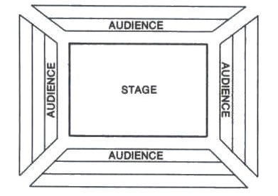
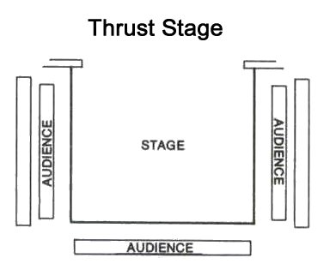
Theatre in the round
Proscenium Arch
Traverse stage
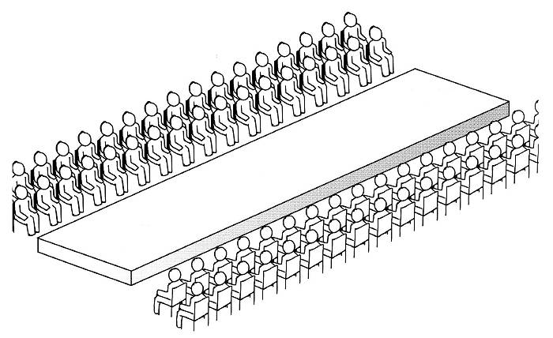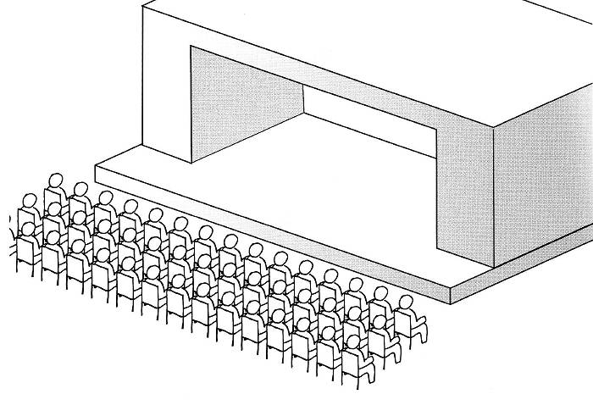
Promenade theatre
- Promenade Theatre is when there is no divide between the actors and the audience
- Actors can enter from anywhere and perform anywhere. This creates a realistic and intimate atmosphere for an audience because they are all within the performance.
- Often audience will have to follow actors around a large space

Can you identify the different areas of the theatre stage?
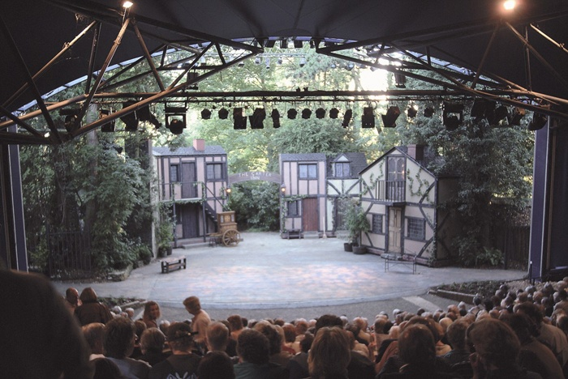
Wings
Upstage

Centre stage

Down Stage
- - Apron - -

Up Stage right

Centre stage right

Down stage right
Up Stage left

Centre stage left

Down stage left
Wings

Drama – technical terms: Make sure you know what these words are, and the effect they have!
Technique | Definition | EFFECT | A good example of this technique will use…
Freeze frame | …is when the actors are still on stage and create an image / photograph of a moment in a scene | Makes the audience aware of the characters’ relationships, and what they are thinking / feeling about the situation. E.g. surprised at a birthday party. | Space, levels, body language, eye contact, gestures etc. to create an effective response.
Thought in the head / monologue | … when an actor speaks to the audience directly | the audience see what the character is really feeling | The audience get the intended response e.g. they feel sympathy for the character. Actor will use varied tone, language etc.
Choral speech and movement (choral narration) | …is when a group of performers (or the ‘chorus’) speak / move together for dramatic effect | moment is marked by people emphasising a point; piece moves away from naturalism. Techniques include: Canon / repetition / synchronised / echo | Use of sound effects, vary tone, rhythm, Canon, repetition, echos, simultaneous speech, physical actions to emphasise words.
Physical Theatre | … is when you use your body to create an object | the cast create the environment for the main actor/s, makes the play abstract | Cast are focused, committed, using teamwork, human operation, smooth transitions in movement/sound
Split scene | …is when more than 1 thing in the scene is happening at the same time, using soft mime/freezing to focus audiences’ attention | Showing the audience where to focus their attention | Good freezes, and soft miming so not to distract audience
Flashback / forward | … is when the action goes back / forward in time. | The audience get a snap-shot into the past of the characters and therefore feel more sympathy / another emotion for the character.  Or sees their dreams and aspirations in the future. | The audience see more about a character’s life which changes their opinion/builds relationship with a character.  It is usually brief, so as not to confuse audience (comes back to present day)
Narration | … is when someone (sometimes more than one actor) speaks to the audience and moves the story along. | Helps the audience understand the journey, explains the plot, reveals the characters backgrounds | A scene change can happen as the audience are distracted. The actors connect vocally and physically with the audience through good use of the ‘gingerbread man’.

The Gingerbread man
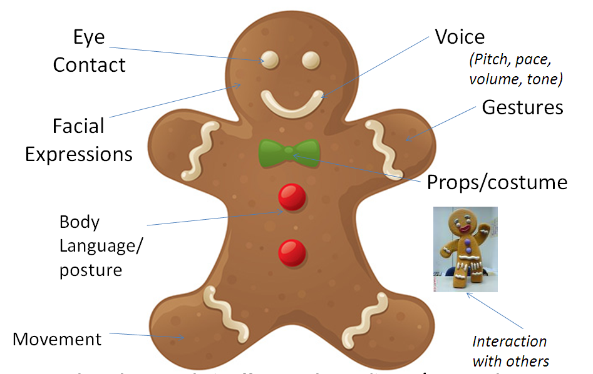
- What = Gingerbread man
- Who is doing the actions (Gingerbread man)
- When is it in the scene
- Why is this effective (what does it tell the audience)
- hoW do they perform this in detail (Gingerbread man)
- Always use the Gingerbread man to support your answers!

GENRES OF THEATRE
Genre: | 5 Stock Characters | Key features of the genre | Locations | Time period
Melodrama | - Hero  - Villain  - Damsel in Distress  - Villain’s sidekick  - Elderly Parent of the damsel | Extreme emotions, asides, over exaggerated gestures, music to announce characters entrance, good versus evil - moral | Train tracks  Villain’s evil Lair | Late 19th century
Commedia Dell Arte | 1. Pantalone 2. Colombina  3. Dottore 4. Lovers (Flavio and Isabella)  5. Zanni or Arlechino or Harlequin  6. Capitano  7. Brighella | Slap stick, farce, ridicule, walking like the character, mask, lazzis, travelling community | Street  Inn / tavern Courtyard | 16th century
Murder Mystery | - Rich Victim  - Butler  - Gold digger  - Lover  - Detective  - Angry former business partner | Dum x3 music, flash backs, split scenes, understated acting, questioning of characters. | Manor house  Train  Castle | Early 20th century
Soap Opera | - Gossip  - Flirt  - Hard man  - Troubled teen  - The Sneak | Over exaggerated plots / storylines, extreme reactions. Affairs, murder, fights, pregnancies etc | somewhere where gossip is ripe e.g. school, pub, laundrette | Contemporary

Think about the pieces you have devised this year, and your role in the group (e.g. melodrama). You will have to write about this. What did you do? (Which role did you play? How did you develop your work? What style was the piece – and what techniques did you use to make it fit that style? Techniques you should think about include: narration, choral narration, choral speech, choral movement, monologues, thought in the head, duologues, dialogue, freeze frames, split scene, flash back, flash forward, slow motion, fast-forward, soundscapes, physical theatre etc.

